Pre-Lab 5: Inverting and Non-Inverting Amplifiers

Part 1: Inverting Amplifier

  - Max supply voltage: +/- 22V
  - Max power consumption: 1000 mW
  - Input resistance: ${10}^{12} Ω$
  - Input offset voltage: 5 mV max
  - Output Resistance: Low Impedance
  - Input offset current: 2 nA max
  - Voltage Gain: 106 dB

  - Pin 1: Balance
  - Pin 2: Inverting input
  - Pin 3: Non-inverting input
  - Pin 4: V-
  - Pin 5: Balance
  - Pin 6: Output
  - Pin 7: V+
  - Pin 8: NC
- The gain is -3 since it is $-\frac{R_{f}}{R_{i}}$, the phase of the output will match the phase of the input exactly since the signal will be multiplied by -3/

- Since the voltage signal is being connected to the inverting input of the OpAmp. The significance of the resistors is their contribution to computing the gain, which is $-\frac{R_{f}}{R_{i}}$

- You can Create an inverting buffer by connecting the voltage input to the inverting input of the OpAmp and then connecting the non-inverting to the output.

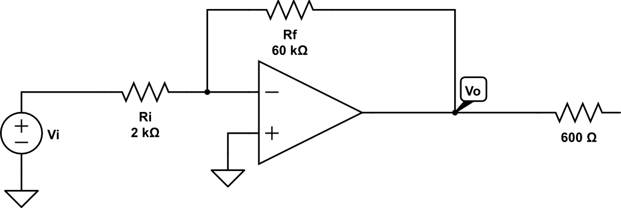
100 $Ω$

- Simulation for circuit 5.1
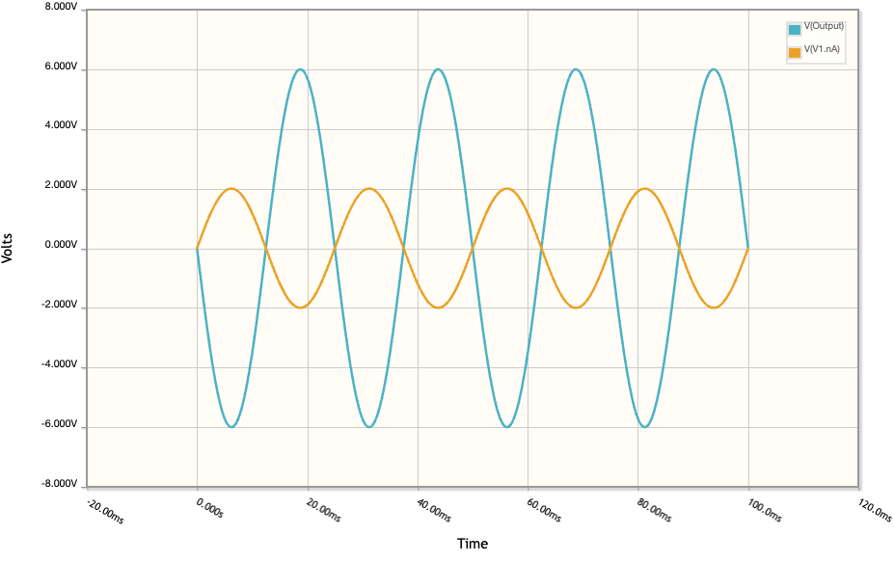
- As seen above, the orange line is the input, which ends up getting inverted, and multiplied by 3, so it has a gain of -3 due to the inverting amplifier, this output is seen for the blue line.

Part 2: Non-Inverting Amplifier
- The closed-loop voltage gain of a non-inverting amplifier is $1+\frac{R_{f}}{R_{i}}$ and the phase of the input will be seen on the output signal since the input signal is multiplied by the gain at each point.

- The circuit is called a non-inverting amplifier because the voltage input signal is connected to the non-inverting input of the OpAmp

- You can create a voltage follower by shorting the inverting input directly to the output.

- Circuit
  - 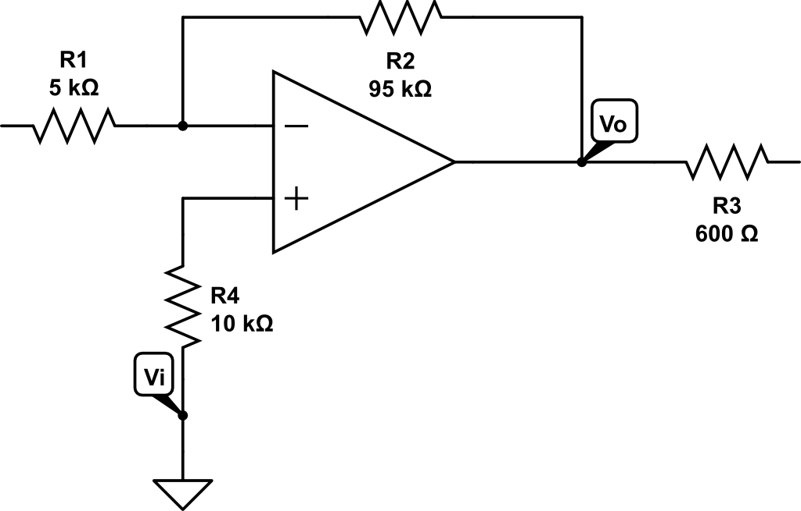
$$R_{i}+R_{f}=\frac{10 V}{0.1 mA}$$
$$R_{i}+R_{f}=100 kΩ$$
$$20=1+\frac{R_{f}}{R_{i}}$$
$$R_{f}=19R_{i}$$
$$20R_{i}=100 kΩ$$
$$R_{i}=5 kΩ→R_{f}=95 kΩ$$

- Simulation
  - 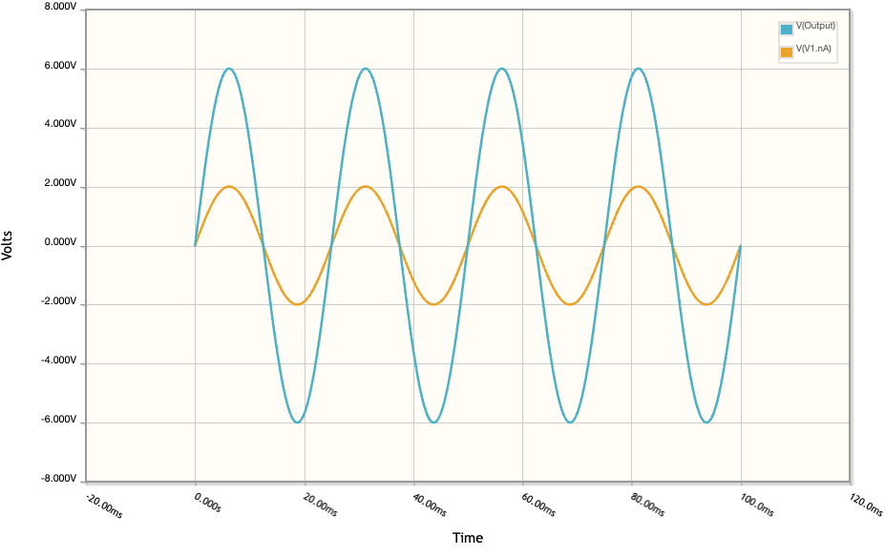
- Orange is input, and blue is output. The input is scaled by 3.

